**Task 3 – Automation Test Script**

**Instruction:**

1. Import the project/Workspace in eclipse IDE
2. Open the TestNG.xml file and click on Run

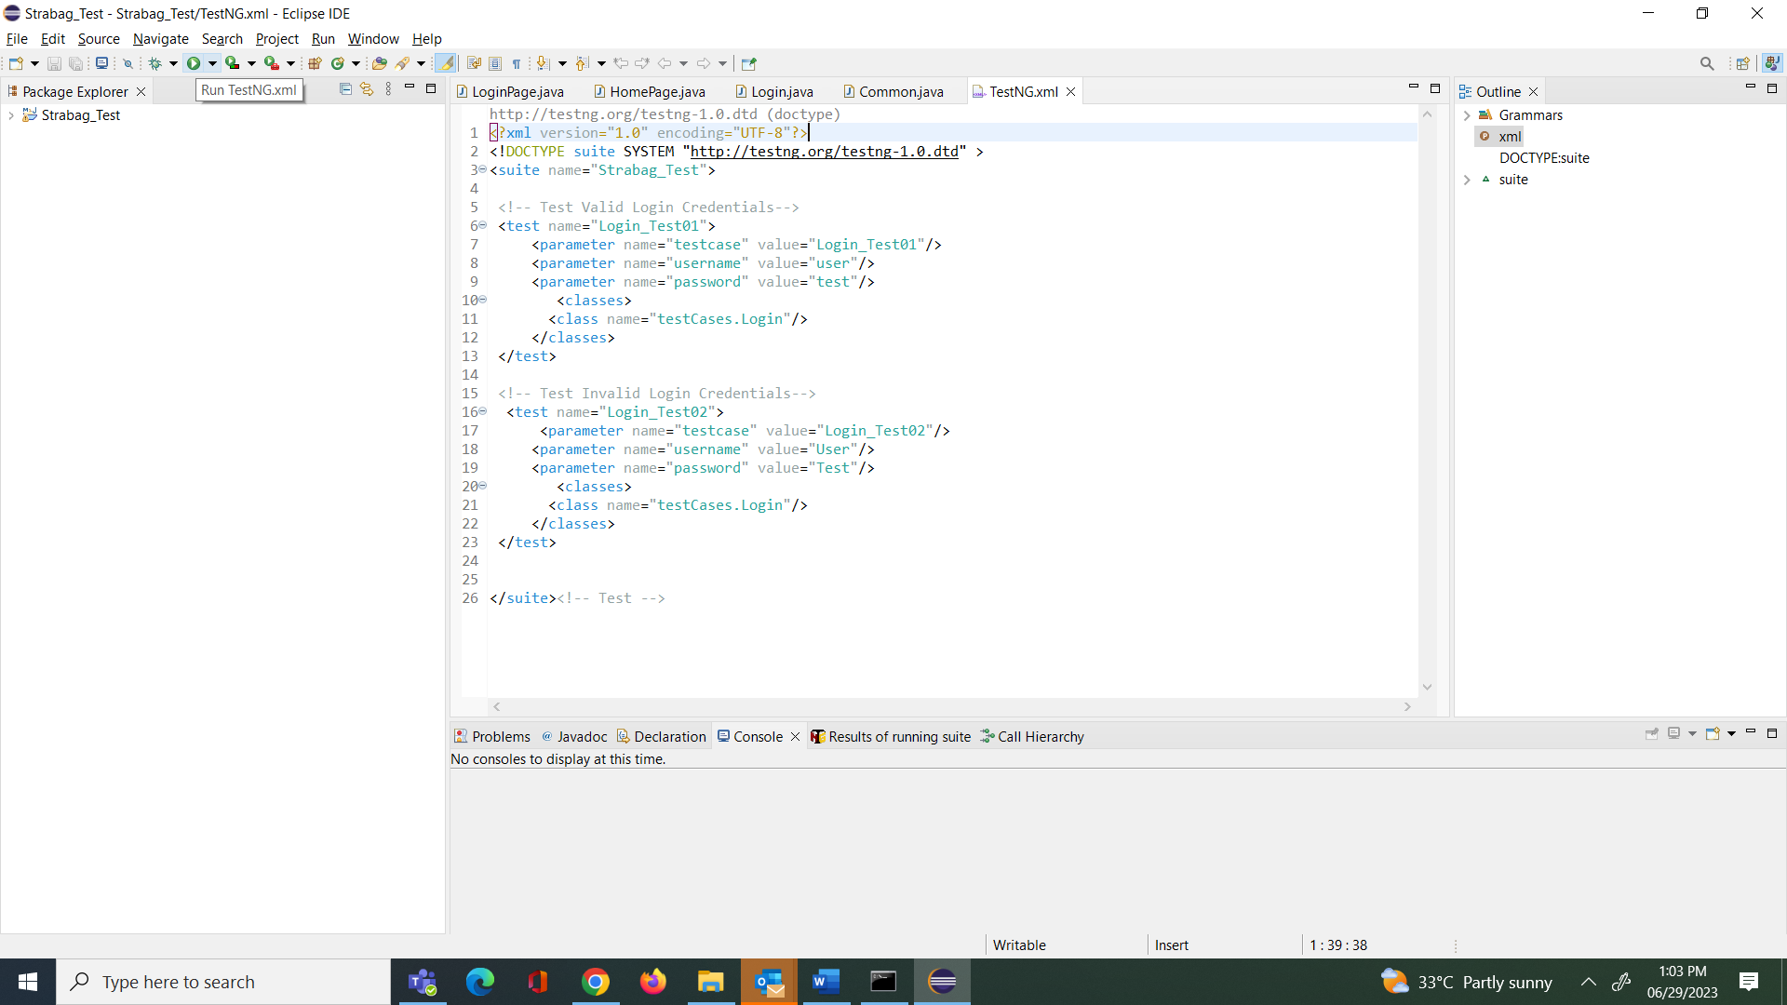

1. Once the execution is completed -> Extent Report file will get generated

Navigate to Test tab

1. To open screen capture Right click on Image ->Open in new Tab
2. A screenshot of a computer

   Description automatically generated